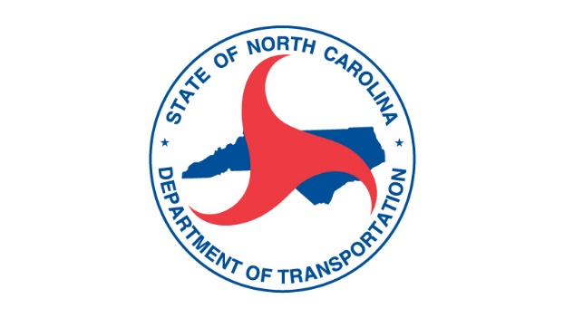**NCDOT NOTICE TO INTERESTED PARTIES – VIRTUAL OPEN MEETING ON PROPRIETARY PRODUCTS**

**FOR TOWN OF PEMBROKE, TRANSPORTATION INVESTMENT FOR REVITALIZATION PROJECT**

**STIP Project No. HL-0009**

**Town of Pembroke –** This open meeting is for any interested stakeholder to participate in a live, virtual, open meeting on **Wednesday**, **December 21** from **1 p.m. to 2 p.m.** to learn more about the performance standards for alternates for the preferred product(s) for the Town of Pembroke, Transportation Investment for Revitalization project.

The purpose of this meeting is to communicate the performance standards for the preferred product(s) and solicit alternatives from manufacturers that the Engineer will consider for approval on this project. The Engineer will give a presentation of the preferred product(s) during the virtual open meeting. Any additional product alternates, submitted prior to the meeting or during the meeting will be discussed by the manufacturer at this meeting.

In accordance with *GS_133.3*, the following preferred product(s) are being considered for the Project:

**Streetlights** manufactured by Holophane, a division of Acuity, *and*

**Pedestals for Outdoor Circuits** manufactured by Pedco Power Solutions.

Documents related to these products will be available for inspection at [**this website**](https://connect.ncdot.gov/resources/Products/Proprietary_Products/Forms/AllItems.aspx?RootFolder=%2Fresources%2FProducts%2FProprietary%5FProducts%2FHL%2D0009&FolderCTID=0x0120000DCE5E0FAC86BB47BD00427CDA9E8E0C&View=%7B60594815%2D26F9%2D4448%2DAF76%2D80905D8DFD04%7D)or by contacting Lester Lowe, PE, with The Wooten Company at 919-828-0531 or via email [llowe@thewootencompany.com](mailto:llowe@thewootencompany.com).

Anyone interested may sign up for the virtual open meeting by going to [**this website**](https://connect.ncdot.gov/resources/Products/Proprietary_Products/Forms/AllItems.aspx?RootFolder=%2Fresources%2FProducts%2FProprietary%5FProducts%2FHL%2D0009&FolderCTID=0x0120000DCE5E0FAC86BB47BD00427CDA9E8E0C&View=%7B60594815%2D26F9%2D4448%2DAF76%2D80905D8DFD04%7D)to review the preferred product(s), and anyone interested in learning about these projects or have an alternate option please click the registration link below:

[Pembroke Transportation Investment for Revitalization Proprietary Products Registration](https://teams.microsoft.com/registration/tP4QACb4dEitkKv9MzNMAA,1Ql1qWzVYkely9Gs88zTUw,0jBQRMImvkyITLmv3WOcnw,_OiM2bLxUEWumWw7F44vFg,3KkQ5NxZWUaWg-rHmgylrA,zmCGAakgzU--oMcXTKezuA?mode=read&tenantId=0010feb4-f826-4874-ad90-abfd33334c00)

The audience may submit questions via a chat box during the virtual meeting or prior to the meeting to [llowe@thewootencompany.com](mailto:llowe@thewootencompany.com).

If you are a manufacturer interested in being considered as an alternate for the Streetlights manufactured by Holophane, a division of Acuity, please fill out the form available at this [Alternate Consideration Form](https://connect.ncdot.gov/resources/Products/Proprietary_Products/HL-0009/Product%20Streetlight/Proprietary%20Approval%20Form_Manufacturer%20TBD_Product%20Streetlights_SubmitPriorToMtgForm.docx) and submit to The Wooten Company, Lester Lowe, PE at [llowe@thewootencompany.com](mailto:llowe@thewootencompany.com) no less than two (2) business days prior to the virtual open meeting on December 21, 2022 from 1 p.m. to 2 p.m.

If you are a manufacturer interested in being considered as an alternate for the Pedestals for Outdoor Circuits manufactured by Pedco Power Solutions, please fill out the form available at this [Alternate Consideration Form](https://connect.ncdot.gov/resources/Products/Proprietary_Products/HL-0009/Product%20PedestalsOutdoorCircuits/Proprietary%20Approval%20Form_Manufacturer%20TBD_Product%20Pedestals%20for%20outdoor%20circuits_SubmitPriorToMtgForm.docx)and submit to The Wooten Company, Lester Lowe, PE at [llowe@thewootencompany.com](mailto:llowe@thewootencompany.com) no less than two (2) business days prior to the virtual open meeting on December 21, 2022 from 1 p.m. to 2 p.m.

Contact NCDOT as soon as possible if you require any accommodations under the Americans with Disabilities Act. Anyone requiring special services should contact Tony Gallagher, Environmental Analysis Unit, at 1598 Mail Service Center, Raleigh, NC 27699-1598, 919-707-6069 or [magallagher@ncdot.gov](mailto:magallagher@ncdot.gov) as early as possible so arrangements can be made.

Those who do not speak English, or have a limited ability to read, speak or understand English, may receive interpretive services upon request prior by calling 1-800-481-6494.  
  
Aquellas personas no hablan inglés, o tienen limitaciones para leer, hablar o entender inglés, podrían recibir servicios de interpretación si los solicitan llamando al 1-800-481-6494.